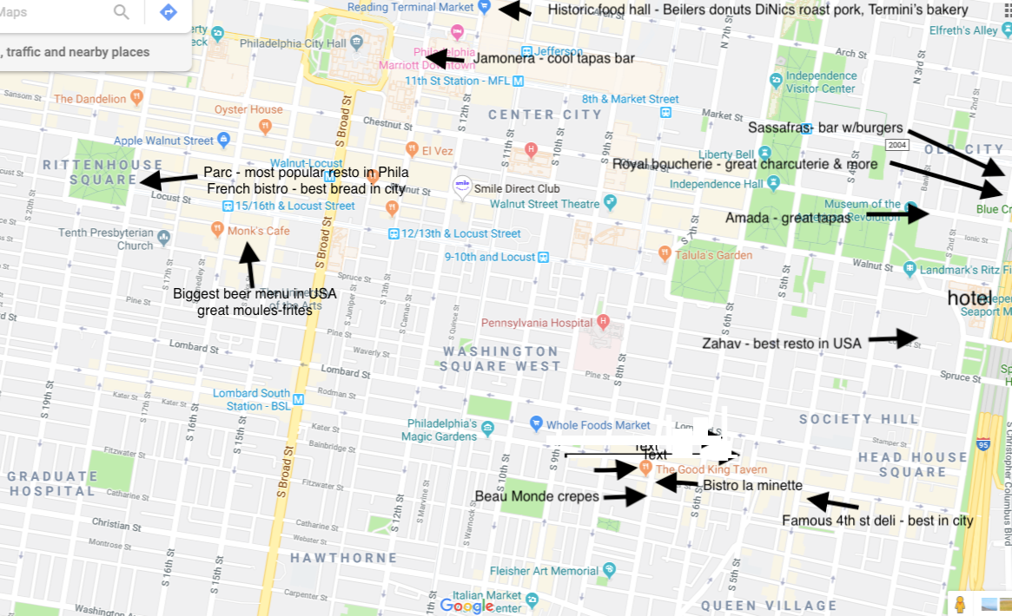

Beau monde crêperie- authentic Breton crepes, savory (bœuf bourguignon great) and sweet
Famous 4th Street deli- amazing corned beef, pastrami, latkes
Zahav – named by James Beard best resto in USA- Isreali cuisine, tough reservation
Amada – stylish tapas spot
Sassafras – great burger dive bar
Royal Boucherie – new bar with charcuterie and French highlights
Monk’s café – Belgian bar w/huge beer list and great moules-frites
Parc – most popular in city-great location-the bread basket is a religious experience
Good King Tavern – French tavern owned by father/daughter pair from Aix – get the socca and steak-frites and duck special
Reading Terminal market – historic food hall with many Philly greats
Bistro la Minette – classic French bistro – website down - 623 s 6th st – 215-925-8000
Jamonera – cool tapas bar w/ great food and drink – they own several terrific restos within a few blocks- check this site

